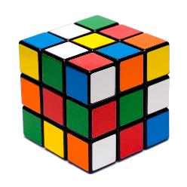
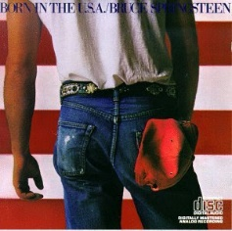
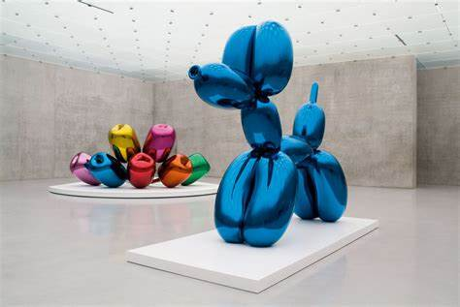
IMAGINE
The 80’s
Music, Art, technology and Fashion
Hello students, this is a fun assignment where you can research what fashion, music and art was popular in the Eighties.
The 1980s in music was the start of musicians rise to superstardom. Artists like Bruce Springsteen, Michael Jackson and Madonna really took off in the 80’s... sadly, with the rise of some, others left us like John Lennon and Bob Marley. The 80’s was also the recording of “We are the World”. Art was Neo Pop or Post Modern Art…artist study of the decade will be Jeff Koons.
If you are able, you can research the 80’s and listen to the music, look up their artwork, study the technology advances like IBM’s Compact Computer or the Disc Man. As you are listening to the music of John Lennon’s Imagine read and think about everything that started in the 80’s (PACMAN, Rubic’s Cube, Trivial Pursuit(Canadian), Cabbage Patch Kids, etc. Look at album cover designs that represent the time and fashion and do nothing but relax and think.
Possible optional assignments:
- Sketch your own album design that reflects the era. Try this with either pencil, crayon, pastel, watercolor, acrylic, etc. if you have the supplies. If you do not just sketch with a pencil for fun and relaxation.
- In Office 365 produce a Power point or Microsoft Word presentation on the musician of your choice from the 70’s. Research where they grew up, their education, most popular songs, hobbies, where they are now, etc. Talk to your parents, grandparents, guardians, etc. about your findings…use the phone and call them (social distancing)
- In Office 365 produce a Power point or Microsoft Word presentation on artist of your choice from the 80’s(Jeff Koons, John Lennon, Madonna, Springsteen, etc.). Research where they grew up, their education, most popular works, hobbies, where they are now, etc. Talk to your parents, grandparents, guardians, etc. about your findings…use the phone and call them (social distancing)
Note: If you are doing a Power Point or Word Presentation play around with the animations and transitions to keep yourself sharp. Try inserting a video or music. Use YouTube for help with any of these options or email me. LeRoy.Vincent@nbed.nb.ca
In your class files for week 3 look at the sketch book prompts file I’ve placed for you to practice…. if you have the time.

